**RESHMA SUBRAMANIAM**

**W1502996**

**COEN 233 FALL 2018**

SUBJECT: IMPLEMENTATION OF REDIS DB ON AWS EC2

**AUDIENCE:**

This document covers the architecture, types..

The reader is expected to have basic knowledge of networks to be able to understand the …

System architects, designers, developers, quality assurance analysts, business analysts, academicians, researchers and technical authors can use this document.

TABLE OF CONTENTS

TABLE OF FIGURES 4

TABLE OF TABLES 5

1. INTRODUCTION TO CLOUD COMPUTING 6

1.1 DEFINING CLOUD COMPUTING 6

1.2 ESSENTIAL CHARACTERISTICS OF CLOUD 6

2. CLOUD TYPES 7

2.1 DEPLOYMENT MODELS 7

2.1.1 Public Clouds 7

2.1.2 Private Clouds 7

2.1.3 Community Clouds 7

2.1.4 Hybrid Clouds 7

Hybrid cloud is a composition of public cloud, private cloud and community cloud. Though hybrid cloud combines multiple clouds, it retains their unique identities. The advantage of hybrid cloud is that it gives greater flexibility and more data deployment options than the other ones. 7

2.2 SERVICE MODELS 8

Figure 2 describes three types of service models. 8

2.2.1 Infrastructure as a Service (IaaS) 8

2.2.2 Platform as a Service (PaaS) 8

2.2.3 Software as a Service (SaaS) 8

3. VIRTUALIZATION TECHNOLOGIES 9

4. AMAZON EC2 10

4.1 INTRODUCTION TO AMAZON ELASTIC COMPUTE CLOUD 10

4.2 BENEFITS OF AMAZON ELASTIC COMPUTE CLOUD 10

CONCLUSION 11

REFERENCES 13

1 Adil Yousif ; Mohamed Farouk ; Mohammed Bakri Bashir, “A Cloud Based Framework for Platform as a Service”, IEEE 13

3 Shiori Toyoshima ; Saneyasu Yamaguchi ; Masato Oguchi, “Storage Access Optimization with Virtual Machine Migration and Basic Performance Analysis of Amazon EC2”, IEEE 2010 13

# TABLE OF FIGURES

# TABLE OF TABLES

# INTRODUCTION TO CLOUD COMPUTING

## 1.1 DEFINING CLOUD COMPUTING

Cloud computing refers to applications and services that run on a distributed network using virtualized resources and accessed by common Internet protocols and networking standards. Two essential concepts of cloud computing are Abstraction and Virtualization. Cloud computing abstracts or hides the details of system implementation from users and developers. Pooling and sharing the resources do virtualization.

1 Cloud computing has emerged as a new computational model to replace the traditional computing model and satisfy the increasing demand for resources, software and infrastructures. Cloud computing is defined as an on demand service in which shared resources, information, software and other devices are provided according to the client's needs at specific period of time

## 1.2 ESSENTIAL CHARACTERISTICS OF CLOUD

2 According to the National Institute of Standards and Technology (NIST), the five essential characteristics of cloud computing are listed below.

1. On-demand self-service
2. Broad network access
3. Resource pooling
4. Rapid elasticity or expansion
5. Measured service.

## 1.3 ARCHITECTURE OF CLOUD COMPUTING

FIGURE 1: CLOUD ARCHITECTURE

## Macintosh HD:Users:Reshma:Desktop:Screenshot 2018-10-24 at 7.20.00 PM.png

FIGURE 1 describes the overview of cloud architecture.

# CLOUD TYPES

## DEPLOYMENT MODELS

Figure 1

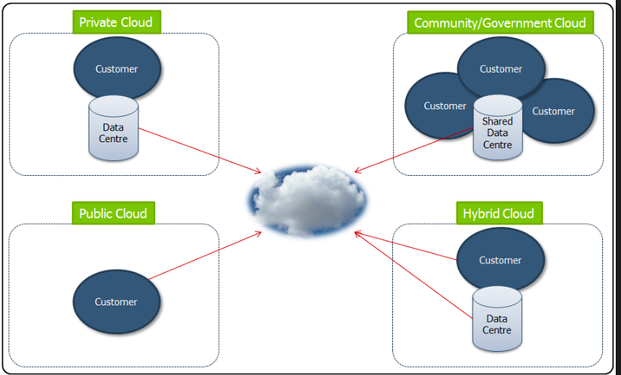

Figure 1 describes the four types of deployment models.

Deployment models refer to location and management of cloud’s infrastructure. It defines the purpose of cloud and nature of how the cloud is located.

### 2.1.1 Public Clouds

The public cloud infrastructure is made available to general public or large industrial group. It is owned by an organization selling cloud services.

### 2.1.2 Private Clouds

The private cloud infrastructure is made available to exclusive use of a private organization. The cloud can either be managed by that private organization or by a third party. Private cloud can be on-premises or off-premises.

### 2.1.3 Community Clouds

Community cloud infrastructure is made available to members of a community. Its in community clouds that cloud is organized to serve a common function or purpose. Third party or constituent single or multiple organizations where the community members belong manages the community clouds.

### 2.1.4 Hybrid Clouds

### Hybrid cloud is a composition of public cloud, private cloud and community cloud. Though hybrid cloud combines multiple clouds, it retains their unique identities. The advantage of hybrid cloud is that it gives greater flexibility and more data deployment options than the other ones.

It doesn’t give any third party datacenters the access to entirety of the data.

## SERVICE MODELS

According to the manner in which infrastructure are deployed, service models are divided into three categories.

Figure 2

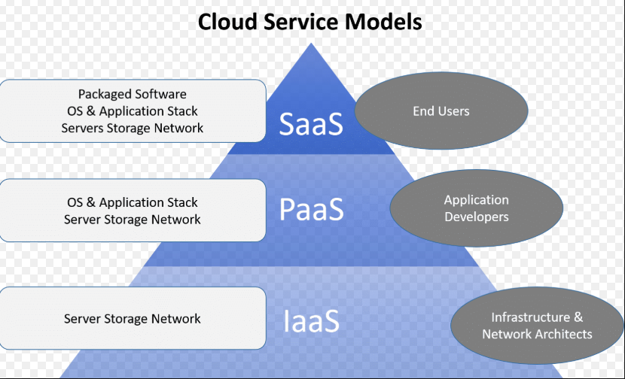

### Figure 2 describes three types of service models.

### 2.2.1 Infrastructure as a Service (IaaS)

Infrastructure as a Service provides virtual machines, virtual storage, virtual infrastructure and other hardware assets as resources to the client. Along with the infrastructure components (server, storage, networking hardware, virtualization), IaaS also provides different services such as detailed billing, load balancing, load clustering, log accesses, backup and recovery and monitoring. User can create a virtual machine, install operating systems in each Virtual Machine, deploy databases, create storage for workloads and install enterprise workload into the created VM. Amazon Web Services (AWS) and Google Cloud Platform (GCP) are examples of independent IaaS. Other examples are GoGrid, Eucalyptus, FlexiScale, Linode, RackSpace cloud and Terremark.

### 2.2.2 Platform as a Service (PaaS)

A PaaS provides integration features, middleware and other services to IaaS model such that it creates platform for customers to develop, run and manage applications without the complexity of building and maintaining the infrastructure associated with launching and developing an app.

Various examples of PaaS are Force.com, GoGrid CloudCenter, Google AppEngine and Windows Azure Platform.

### 2.2.3 Software as a Service (SaaS)

SaaS implements pay-as-you-go model for the application that run in the cloud. Hence, customer can use the applications as and when needed. Customer need not care about how the application is installed, how it is maintained or its upkeep. SaaS is complete operating environment with applications, user interface and management. Various examples of SaaS are GoogleApps, Oracle On-Demad, SalesForce.com and SQL Azure.

# VIRTUALIZATION TECHNOLOGIES

Virtualization is one of the hardware reducing, cost saving and energy saving technology that is rapidly transforming the IT landscape and fundamentally changing the way that people compute. The advantage with virtualization is reduction of IT costs while improving efficiency, flexibility and utilization of the existing computer hardware. Its possible to run multiple applications and multiple operating systems on the same server at same time.

# AMAZON EC2

## 4.1 INTRODUCTION TO AMAZON ELASTIC COMPUTE CLOUD (EC2)

Amazon Elastic Compute Cloud (EC2) offers elastic resources upon user demands, which can be provisioned immediately even if the system is overloaded. 3 In the back-end of Amazon EC2, server virtualization technology is used and users can back up whole image of own OS. EC2 also implements pay-as-you-use model.

EC2 is the backbone of Amazon Web Services (AWS). It truly redefines how IT departments operate. Amazon EC2 provides a web service that allows creating secured and resizable compute capacity in the cloud. We can instantly launch instances of any size, operating systems and configuration to meet any practical demands.

## 4.2 AMAZON MACHINE IMAGES

### 4.2.1 AMAZON MACHINE IMAGE INSTANCE TYPES

**TABLE 1: AMAZON MACHINE IMAGE INSTANCE TYPES**

## Macintosh HD:Users:Reshma:Desktop:Screenshot 2018-10-24 at 7.00.25 PM.png

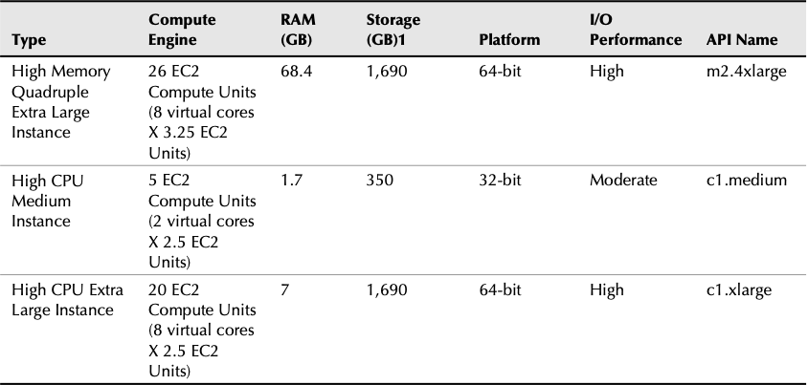

Table 1 shows different Amazon Machine Image Instance types available on EC2.

### 4.2.2 THREE DIFFERENT PRICING MODELS FOR EC2 AMIs

#### 4.2.2.1 On-Demand Instance

#### 4.2.2.2 Reserved Instance

#### 4.2.2.3 Spot Instance

## 4.3 OPERATING SYSTEMS OFFERED

## 4.4 EC2 SERVICE ZONES

Amazon offers EC2 instance creation across the following regions/zones.

### 4.4.1

### 4.4.2

### 4.4.3

### 4.4.4

# 5. IMPLEMENTATION OF REDIS DATABASE ON EC2

# CONCLUSION

# REFERENCES

# 1 [Adil Yousif](https://ieeexplore-ieee-org.libproxy.scu.edu/search/searchresult.jsp?searchWithin=%22First%20Name%22:%22Adil%22&searchWithin=%22Last%20Name%22:%22Yousif%22&newsearch=true); [Mohamed Farouk](https://ieeexplore-ieee-org.libproxy.scu.edu/search/searchresult.jsp?searchWithin=%22First%20Name%22:%22Mohamed%22&searchWithin=%22Last%20Name%22:%22Farouk%22&newsearch=true); [Mohammed Bakri Bashir](https://ieeexplore-ieee-org.libproxy.scu.edu/search/searchresult.jsp?searchWithin=%22First%20Name%22:%22Mohammed%20Bakri%22&searchWithin=%22Last%20Name%22:%22Bashir%22&newsearch=true), “A Cloud Based Framework for Platform as a Service”, IEEE

2 <https://www.nist.gov/news-events/news/2011/10/final-version-nist-cloud-computing-definition-published>

# 3 [Shiori Toyoshima](https://ieeexplore-ieee-org.libproxy.scu.edu/search/searchresult.jsp?searchWithin=%22First%20Name%22:%22Shiori%22&searchWithin=%22Last%20Name%22:%22Toyoshima%22&newsearch=true); [Saneyasu Yamaguchi](https://ieeexplore-ieee-org.libproxy.scu.edu/search/searchresult.jsp?searchWithin=%22First%20Name%22:%22Saneyasu%22&searchWithin=%22Last%20Name%22:%22Yamaguchi%22&newsearch=true); [Masato Oguchi](https://ieeexplore-ieee-org.libproxy.scu.edu/search/searchresult.jsp?searchWithin=%22First%20Name%22:%22Masato%22&searchWithin=%22Last%20Name%22:%22Oguchi%22&newsearch=true), “Storage Access Optimization with Virtual Machine Migration and Basic Performance Analysis of Amazon EC2”, IEEE 2010